
THE G8 EXAMINATION
Kenya Certificate of Secondary Education
FORM 4 TERM 2- JUNE 2026
312/1 GEOGRAPHY
PAPER 1
TIME: 2 HOURS 45 MINUTES

Name: ________________________________________Adm No. _________
Class: _________ Candidate’s Signature: __________ Date: _______________

INSTRUCTIONS TO CANDIDATES.
Write your name, admission number and class
- This paper has two sections A and B
- Answer ALL the questions in section A.
- In section B answer questions 6 and any other TWO questions.
- Candidates should check to ascertain that all pages are printed and that no questions are missing.

For examiners use only
SECTION A | QUESTION 6 | QUESTION 7 | QUESTION 8 | QUESTION 9 | QUESTION 10 | TOTAL

SECTION A: Answer ALL questions in this section.
1)a)Define the term weather. (2marks)
b) State three ways through which air rises to form rainfall. (3marks)
2.a) Give two examples of intrusive igneous rocks. (2marks)
b) State three characteristics of sedimentary rocks. (3marks)
3.Describe the continental drift theory. (5marks)
4.a) Name two fresh fault lakes in Kenya. (2marks)
b) State three characteristics of lakes formed through faulting. (3marks)
5. The diagram below represents some features formed in Karst landscape.
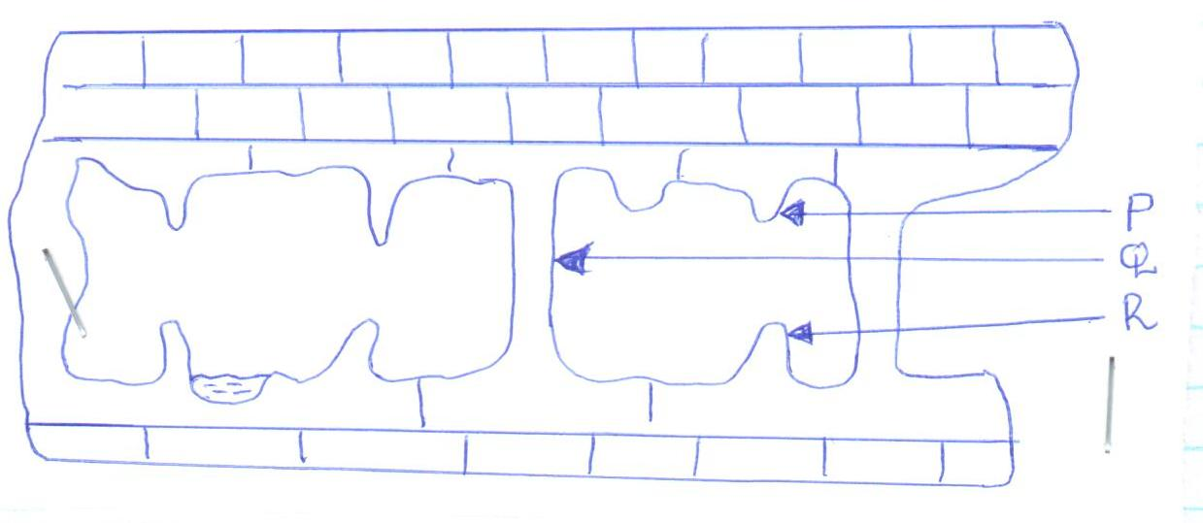
    - State the features labelled P, Q and R. (3marks)
    - State two conditions for the formation of an artesian well / basin. (2marks)
SECTION B:Answer question 6 and any other TWO questions from this section.
6. Study the map of KIPKABUS 1:50,000 (sheet 104/1) provided and answer the following questions.
(a) (i) What is the magnetic variation of the area covered by the map. (2marks)
(ii) Identify three physical features in grid square 8237. (3marks)
(iii) Convert the ratio scale on the map to a statement scale. (2marks)
(b) Describe distribution of natural vegetation in the area covered by the map. (5 marks)
(c)Using a scale of 1cm to represent 20 metres draw a cross section along Northing 40 to the west of Easting 84
(4marks) On the cross section mark and label the following
-River (1mark)
-Plantation (1mark)
-District boundary (1mark)
d) Citing evidence from the map state three economic activities carried out in the area covered by the map.
(6 marks)
7.(a)(i) What is faulting? (2 marks)
(ii) Give three types of fault. (3 marks)
b(i) Apart from the Rift valley, list three features formed as a result of faulting (3 marks)
(ii) Using well labeled diagrams, describe formation of rift valley by tensional forces (8 marks)
c) Explain two ways in which faulting influences drainage (4 marks)
d.(i) Give three natural causes of earthquakes (3marks)
(ii)Name two major earthquake zones of the world (2marks)

8 (a) (i) Differentiate between natural and semi natural vegetation. (2marks)
(ii) State two reasons why the mountain top has no vegetation. (2marks)
b)i) Name the temperature grassland found in the following countries.
- Canada. (1mark)
- Russia. (1mark)
- Australia. (1mark)
(ii) Describe the characteristics of the savannah vegetation. (5marks)
c) Explain three ways in which desert vegetation adapts to climatic conditions. (6marks)
d) You are planning to carry out a field study of the vegetation within the local environment. (i) State three preparations you will make for the field study. (3marks)
(ii) Prepare a work schedule for the field study. (4marks)

9.a(i)What is a river (2marks)
(ii)Name three types of rivers (3marks)
(iii) Explain the three types of river erosion (6marks)
b) Use the diagram below to answer the questions that follow
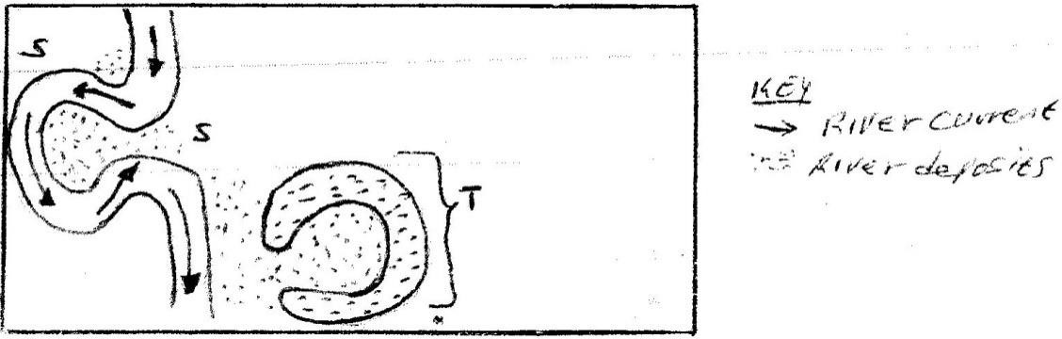

- Identify the feature marked T (1mark)
(ii) State three conditions that leads to the formation of the feature Identified in b(i) (3marks)
c) Give four factors that facilitate river deposition (4marks)
d) Geography students from Baraka School carried out a field study in the old stage of a river
(i) State three ways they could have used to collect data (3marks)
(ii) Name three features they could have observed (3marks)
10(a)(i) Define the term glaciation. (2 marks)
(ii) Name three ways in which ice moves outwards from its area of accumulation. (3 marks)
(b) State three factors that influence glacial erosion. (3 marks)
C) The diagram below shows some features of glaciation erosion. Use it to answer the questions that follow.
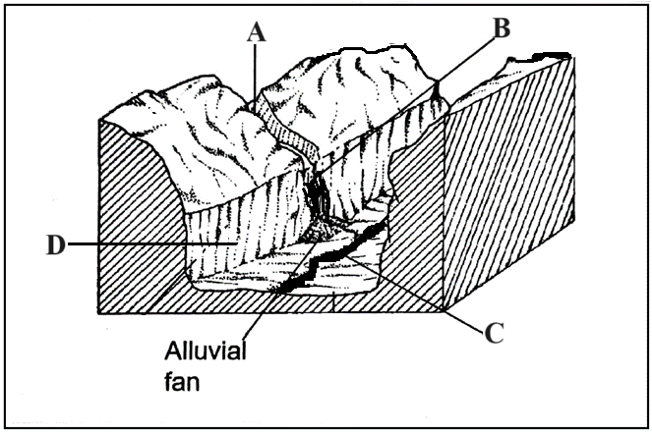
(i) Name the parts labeled A, B and C. (3 marks)
(ii)Describe how the part labeled D is formed. (5 marks)
d)(i)List three depositional features of glaciation in lowland areas. (3 marks)
(ii).Explain three negative effects of glaciation on the human environment. (6marks)

